Login screen

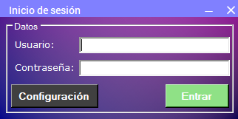

The login screen, as is, the first window shown, requests the user to enter their login credentials. For the first blank field, one shall enter their username. Likewise, in the second field, the password.

Enter button: allows the user with permissions to enter the program.

Setup button: enters the program settings window**.**

Configuration screen

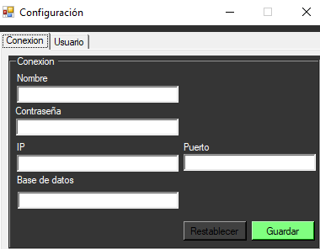

The first thing the user could appreciate is the several text fields allowing the user to add or modify login info, each field with their corresponding datatype.

* Reset button: Allows you to restore the default values, or save the data entered at the time.
* Save button: saves the connection data and establishes the connection.

Users tab

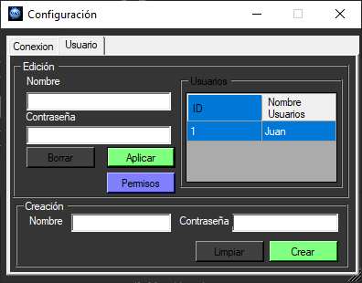

This tab displays the users who are registered in the program.

Apply button: Applies the changes made, either to the name and/or password of the user selected from the table.

Delete button: Removes the selected user from the table.

Permissions button: Opens a window with a list of the permissions that are assigned, the administrator selects the permissions that the user will have and to which part of the program he will be able to enter.

Create button: Allows you to create a new user.

Home screen

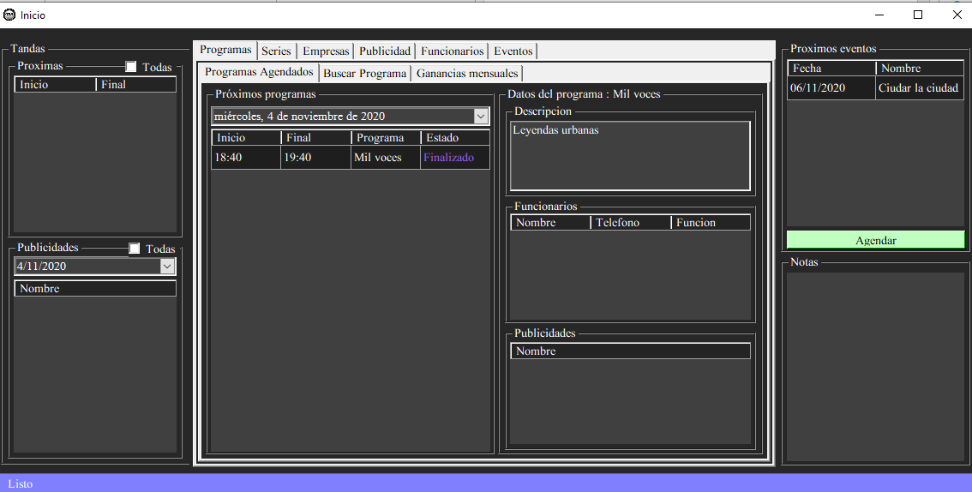

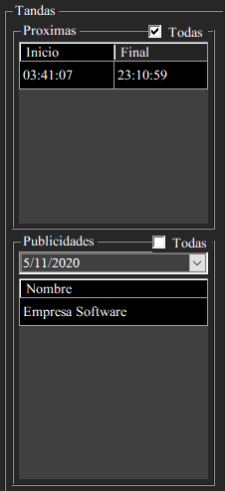

a- The left region of the main interface is dedicated to batches.

The upper division can display the next batches, showing the start time and the end time, selecting the check "all" shows all the batches. While the lower division shows the topics of the advertisements, along with the date, which the user can search for a specific one, selecting the check "all" shows all the advertisements from that day.

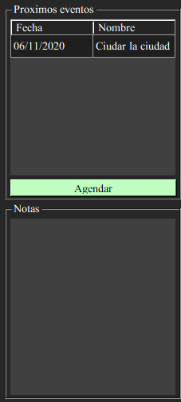

b- The right region of the interface, in the upper division, is dedicated to upcoming events, showing the name and date of the event, the schedule button opens a shortcut to schedule an event. In the lower division there is a note box for the user to write some reminders.

c- Several tabs are displayed in the central region.

Programs tab:

Scheduled Programs: The next programs are displayed, in which you can select the date you want and the assigned programs will be shown with their corresponding data.

Clicking on any program on the left side will show more information about that program.

Search program:

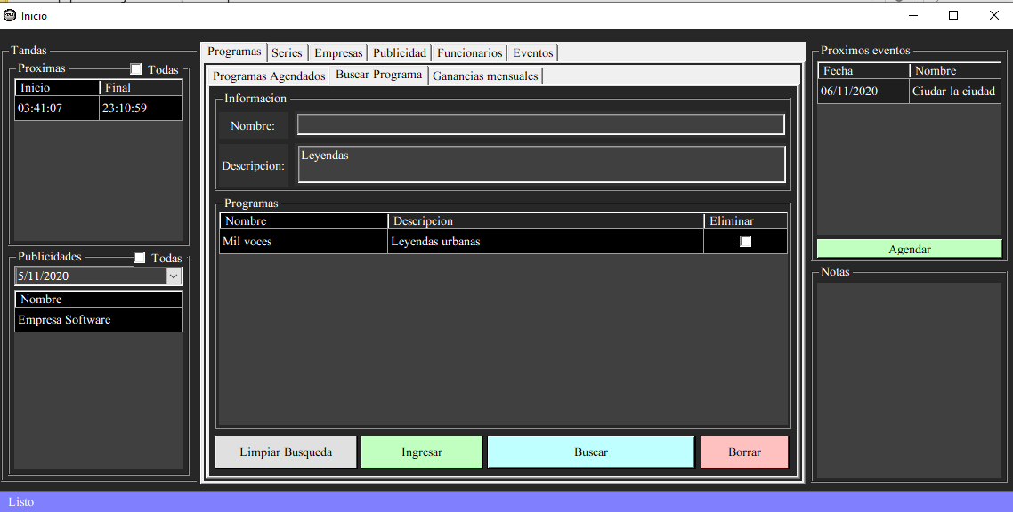

Search button: when entering data in the upper fields, these programs are searched

Enter button: the data entered in the fields will be entered as a new program.

Delete button: deletes the selected program from the table.

Clear search button: clears the list of programs in the table.

Clicking on a program after being searched opens a new tab with specific options:

- Data tab: The data of the selected program are displayed, here you can edit the data or delete it.

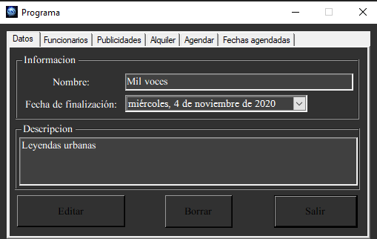

* Employees's tab: It shows the information of the employees who operate in that program. When you select an employee and click on the finish button, the function of the employee in the program is removed, or if you click on the continue button, the employee will continue with the same function in the program.
* - Advertisements tab: Shows the advertisements that are in that program.
* Delete button: Deletes the advertisements from the program that are selected.

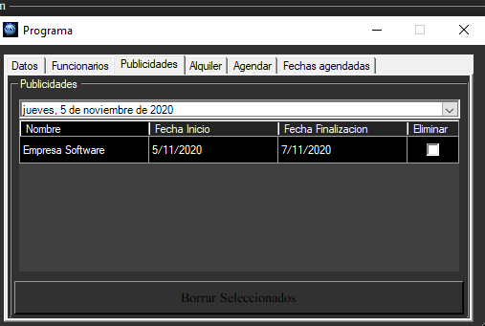

Rental tab:

Adds the program rent, entering the program start date, payment date (you can select that the rent is already paid), and its rental value.

The program rent information is displayed, showing the emission date, the payment date, and its value, this information can be filtered according to the rents that are already paid and the year. The last column removes the rent you are selecting.

- Agenda tab:

Agenda button, a new program is added with the information of the upper boxes, which are the day of emission of the program, the start time and the end time.

In the table, the programs are shown according to their date, allowing the user to visualize their start date, their end date. Selecting the column "delete" it is removed. The programs can be filtered by months.

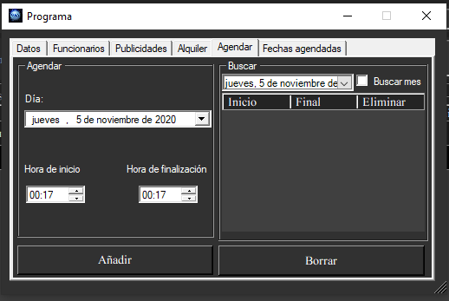

- Scheduled Dates tab: Shows the programs that are scheduled, you can display the programs that are searched for in the calendar on the right.

.

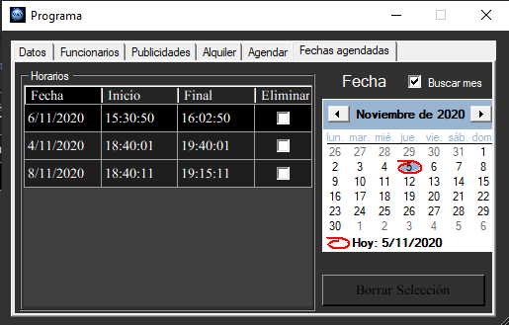

Monthly profit tab: This tab shows a graph, which shows the profit in the month that generated that program.

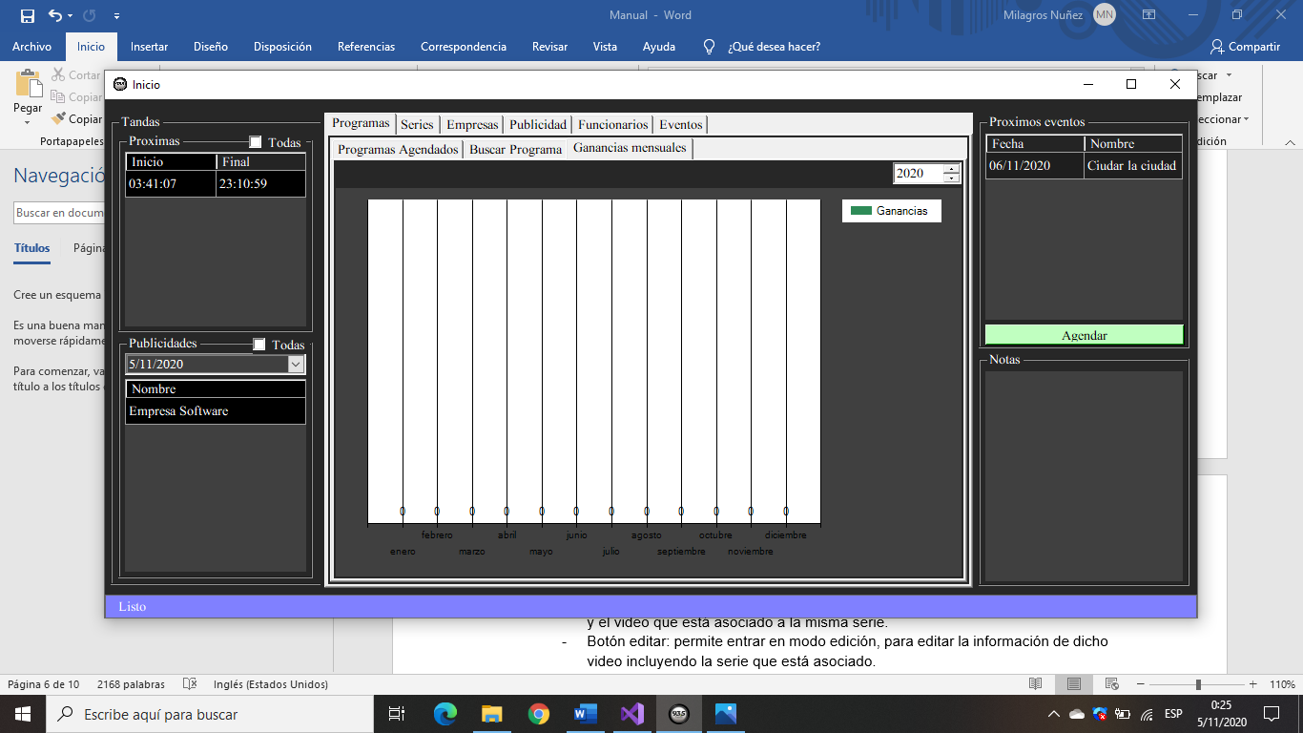

Series tab:

Search serie:

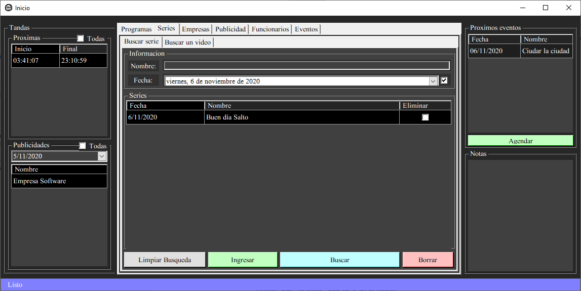

- Search button: when you enter data in the upper fields, the search is done for these series according to the name or date of the series.

- Enter button: the data entered in the fields will be entered as a new series.

- Delete button: delete the series selected in the table.

- Clear search button: clears the list of series in the table.

- Clicking on a series displays another sale:

- Data tab: displays the data of the selected series, plus the date and the video that is associated to the same series.

- Edit button: allows you to enter in edit mode, to edit the information of that video including the series that are associated.

o Edit mode:

o Save button: Saves the changes made.

o Cancel button: Discard the changes made.

- Delete button: allows you to delete the video and disassociate the video with the series.

- Exit button: allows you to exit this window.

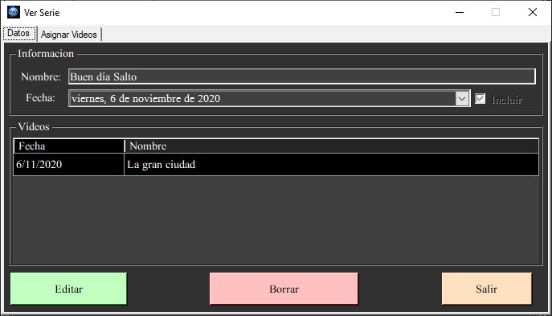

Assign video tab:

Search button: allows you to search the videos that are not associated with a serie by filtering by name and date.

Assign button: Assigns the selected videos shown in the table on the left to this tab.

Unassign button: Allows to remove the link between the series and the selected videos in the table on the right.

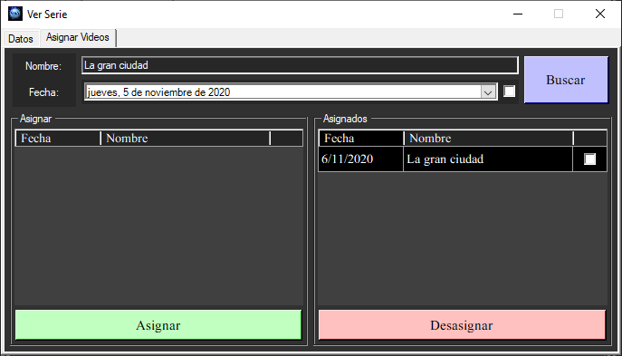

Search video:

-Search button: Searches the videos with this information entered in the fields, in the same way the date can be included to search it, according to the name or content.

-Enter button: The data entered in the fields will be registered as a new video.

-Delete button: delete the selected video from the table.

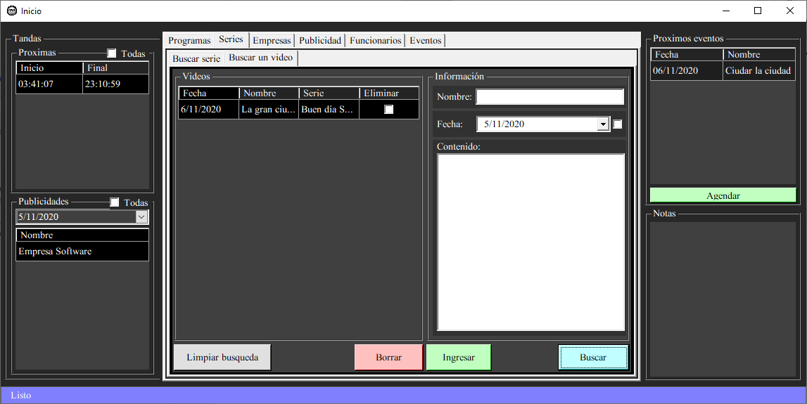

Clicking on a video displayed in the table opens another tab, showing the data of the selected video.

- Edit button: allows you to enter the edit mode, to edit the information of that video including the series that are associated.

o Edit mode:

o Save button: Save the changes made.

o Cancel button: discard the changes made.

- Delete button: delete the video and disassociate the video from the series.

- Exit button: Exit this window.

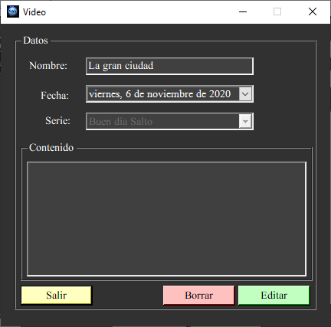

Companies tab:

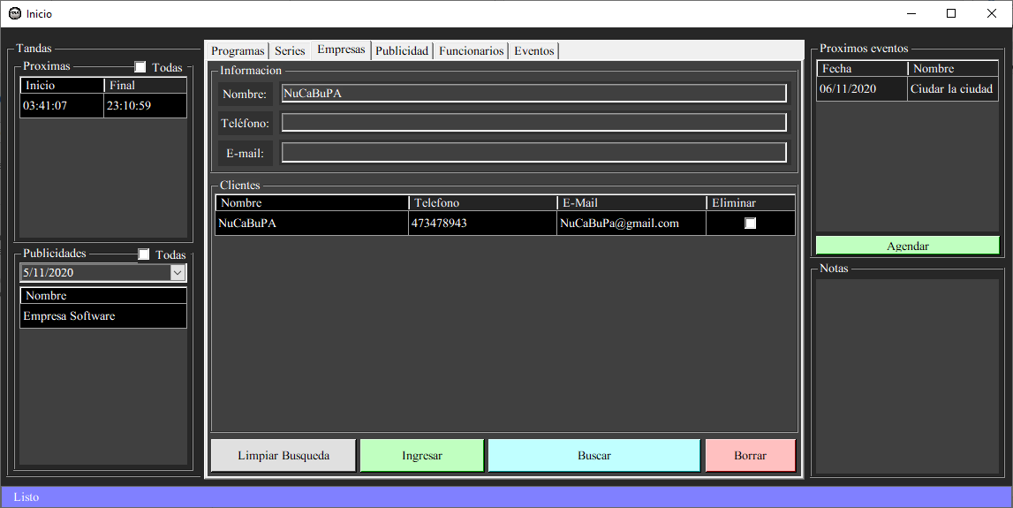

Search button: when entering data in the upper fields, it looks for the information about the customers/companies.

Enter button: When entering data in the upper fields, the information is entered and a new client is registered.

Delete button: Deletes the client that is selected in the table.

Clear search button: clears the list of clients in the table..

When you click on a company shown, another window is opened showing the data of the selected company along with the advertising that this company hired

- Edit button: allows you to enter into edit mode, to edit the information of that company

o Editing mode:

o Save button: Saves the changes made.

oCancel button: Discards the changes made.

- Delete button: Clears the company data.

- Exit button: Exit this window.

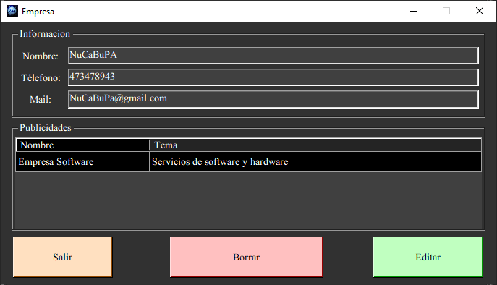

Advertising tab:

Search tab:

Search button: when entering data in the upper fields, the information of the advertisements is searched, they can be searched according to the date, name and/or by the company that hired them.

Enter button: When you enter the information in the upper fields, a new advertisement is registered.

Delete button: Deletes the advertisement selected in the table.

Clear search button: clears the list of advertisements in the table.

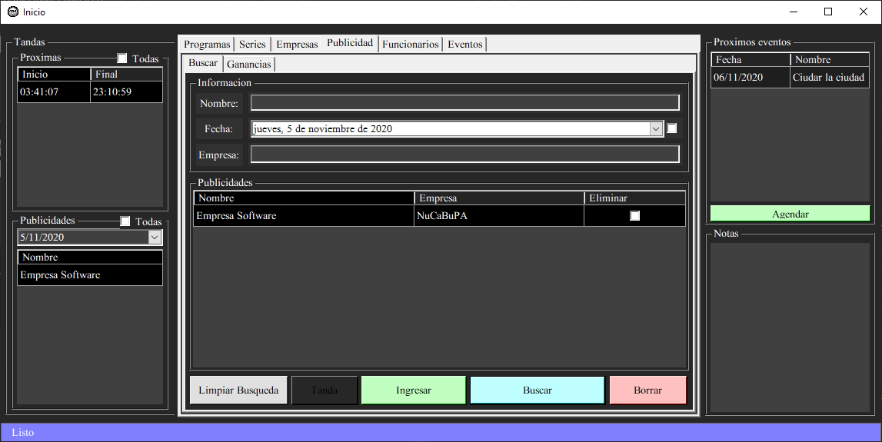

Button batch: Opens a window showing all the batches in stock.

- Enter button: Allows you to enter a batch (If a batch is added on top of an existing batch so that both share at least one day, they will be merged into one large batch), you can enter the start and end time.

- Delete button: Allows you to delete the batch(es) selected in the table shown.

- Exit button: Exits the window.

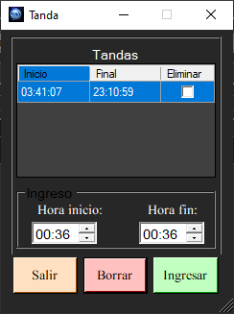

* Clicking on an advertisement displayed in the table opens another tab, showing the data of the selected video.
* Data tab:

- Edit button: Allows you to enter in edit mode to edit the information of that advertisement, its name, its theme and the company that hired it.

o Edit mode:

o Save button: Saves the changes made.

o Cancel button: Discards the changes made.

- Delete button: Allows you to delete the advertisement.

- Exit button: Allows you to leave this window.

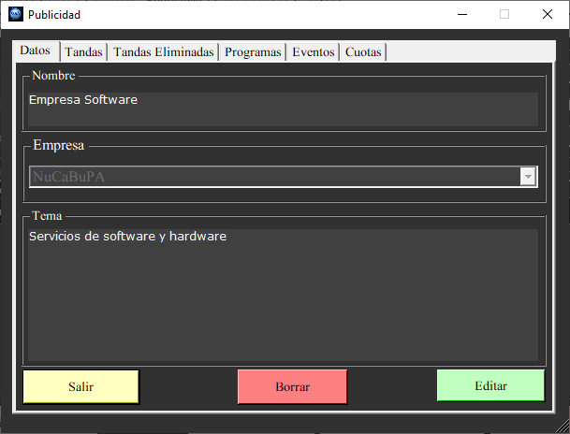

Sets tab:

- Enter button: Allows to associate the advertisement to a selected batch from a start date to an end date.

- Delete button: Deletes the association between the batch and the advertisement on the selected date.

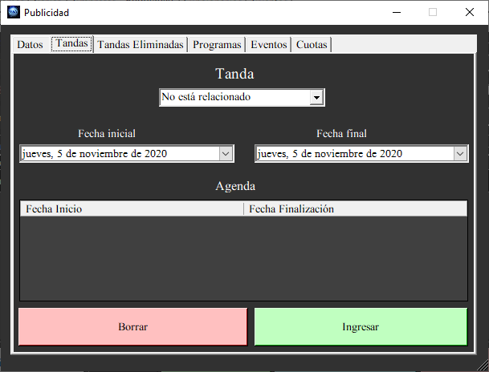

Deleted batches tab: Displays the ads assigned to the batches that were assigned, allowing you to delete the batch you are selecting in the table below permanently.

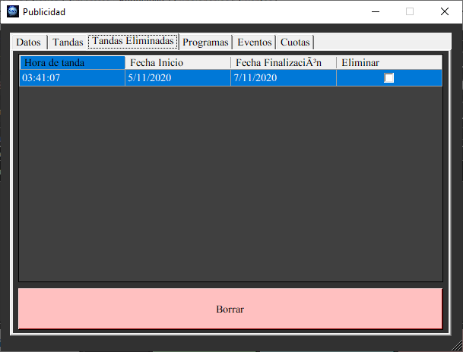

Programs tab and Events tab:

- Search button: Allows to search according to the name, loading the data in a drop-down list.

- Delete button: Allows you to delete the data.

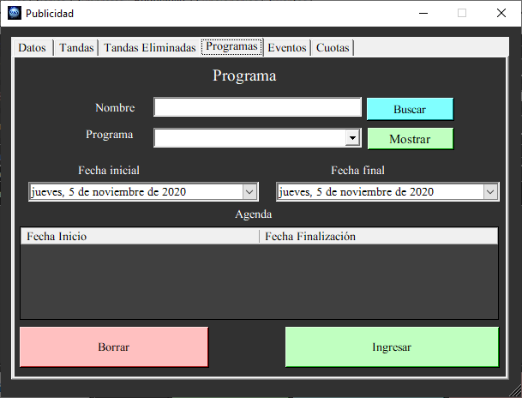

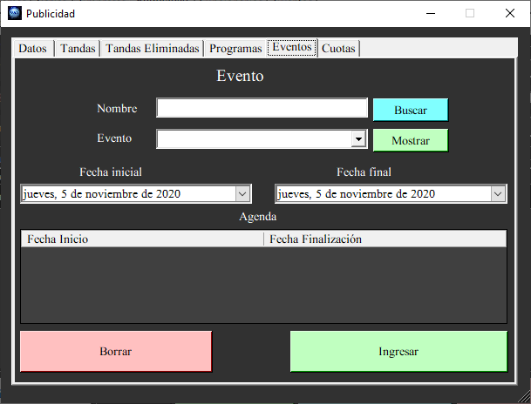

* Quota tab:

It displays the fees in the table in the upper section, in this you can filter according to the year of entry and if the fee is paid.

- Add button: Enter a new fee with the data of emission dates, payment date of the fee, its value and you can include if the fee is paid or not.

* Profit tab: This tab shows a graph, which shows the profit in the month that generated that program.

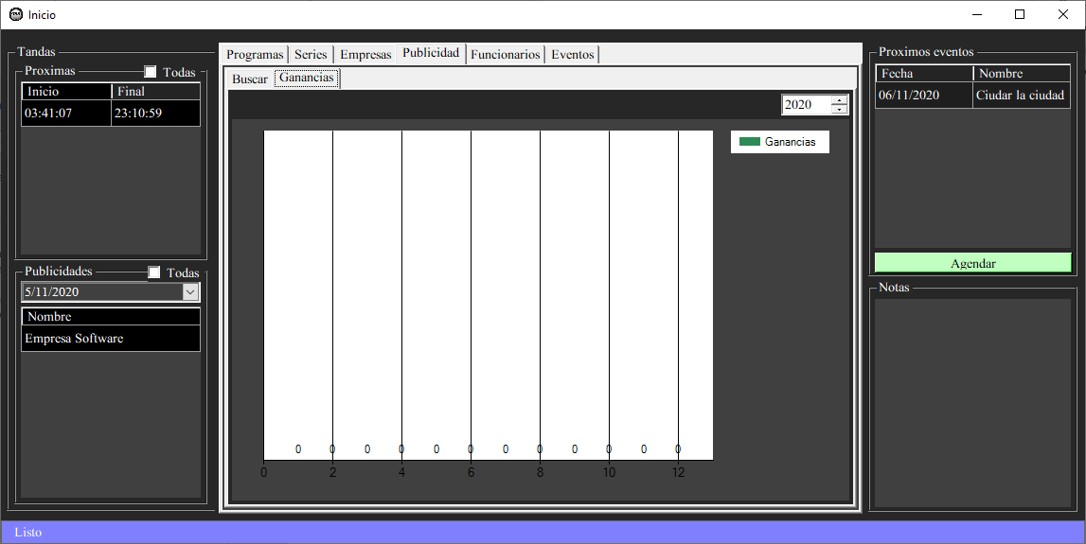

Employee:

Employee search button:

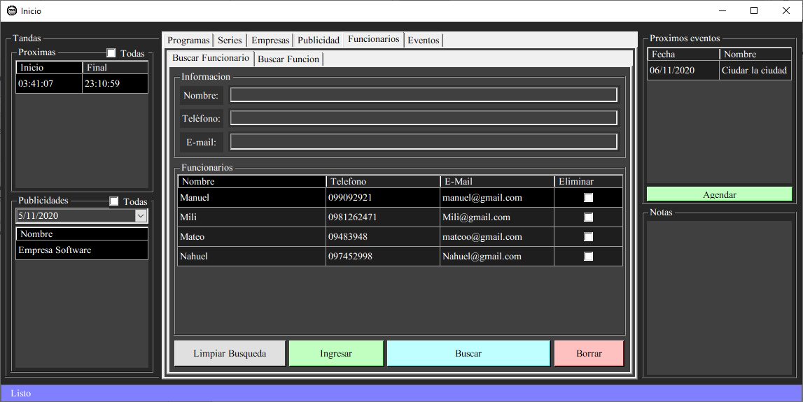

Search button: when entering data in the upper fields, the information is searched for the officials who are registered, showing their contact details in the table.

Enter button: The information is entered in the upper fields and a new official is registered.

Delete button: Deletes the official selected in the table.

Clear search button: clears the list of officials in the table.

Clicking on an official displayed in the table opens another window, showing the data of the selected official.

Data tab:

Edit button: Allows you to enter into edit mode, to edit the information of that advertisement, its name, its subject and the company that hired it.

Edition mode:

Save button: Saves the changes made.

Cancel button: Discards the changes made.

Delete button: Deletes the advertisement.

Exit button: Allows you to leave this window.

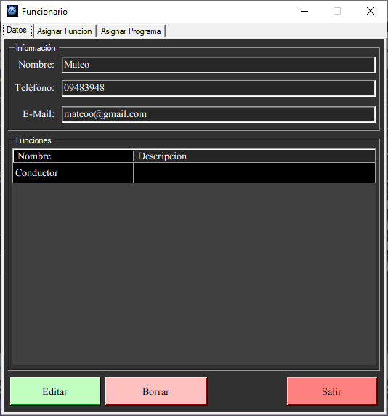

Search button: Allows to search the functions, filtering by name and description.

Assign button: Assigns the selected functions shown in the table.

Unassign button: Allows to remove the link between the official and the functions that are selected in the table below.

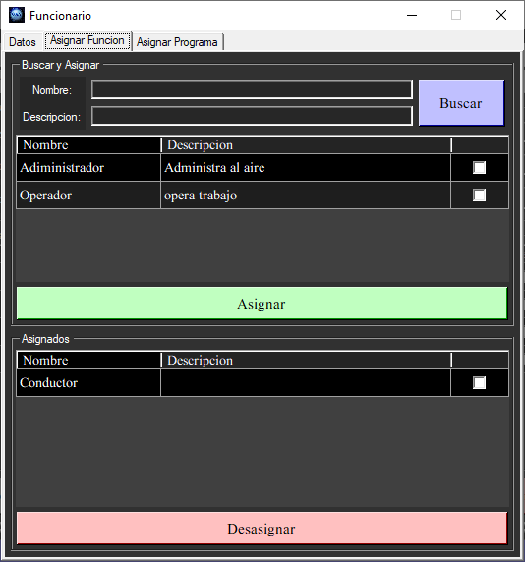

Assign program tab:

Search Button: Allows you to search for programs

Show button: Displays the data of the selected program in a list.

Assign button: Assigns the programs that are selected in the list to that

official, in addition to marking the initial date and the final date of

how much you will work on it.

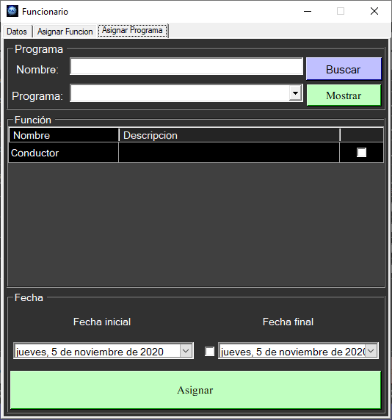

Search function tab:

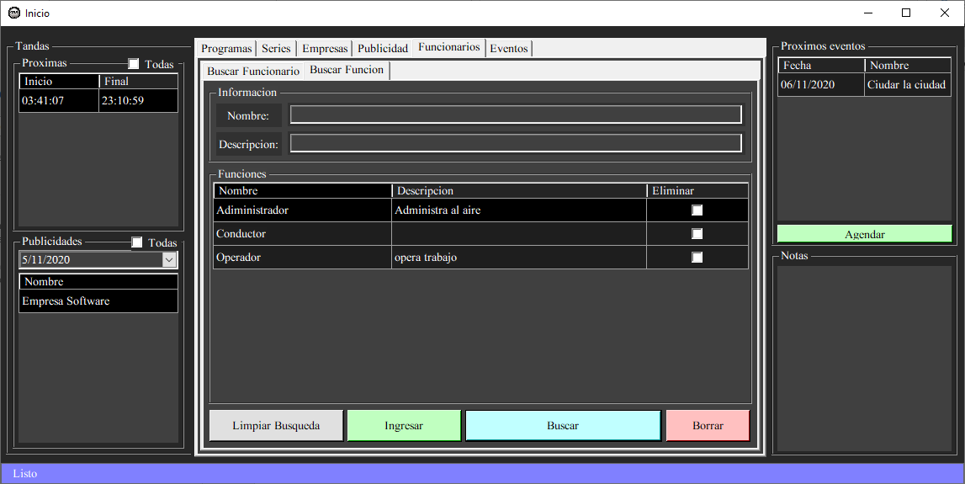

Search button: when entering data in the upper fields, the name and description of the function are searched, and shown in the table below.

Enter button: the information is entered in the upper fields and a new function is registered.

Delete button: delete the function that is selected in the table.

Clear search button: clears the list of functions in the table.

Clicking on a function opens a window for editing the function

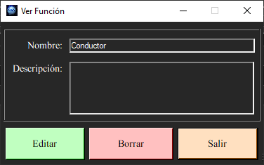

Event tab:

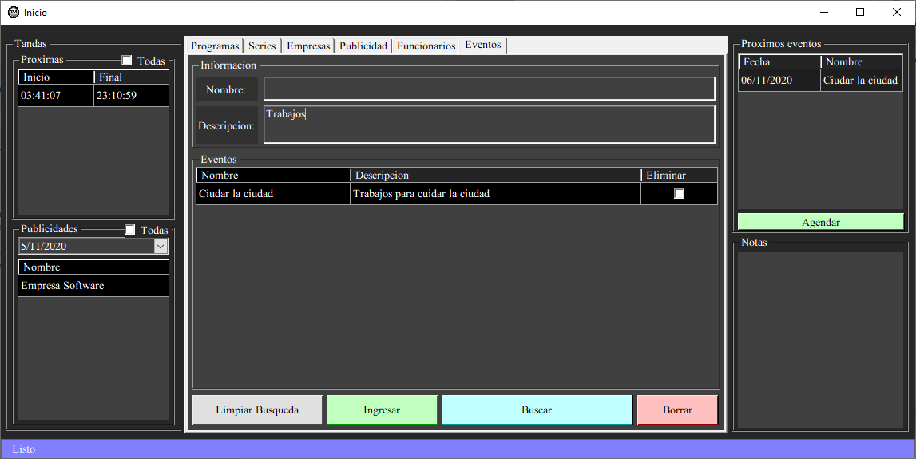

Search button: when you enter data in the upper fields, the events are searched for and displayed in the table.

Enter button: The information is entered in the upper fields and a new event is recorded.

Delete button: deletes the event that is selected in the table.

Clear search button: clears the list of events in the table.

Clicking on an event displayed in the table opens another window, showing the data of the selected event and a series of tabs:

Data tab:

* Edit button: Allows to enter in edit mode, to edit the information of that event, its name, if it is related to any video and description.
* Edit mode:
* Save button: Saves the changes made.
* Cancel button: Discard the changes made.
* Delete button: Allows to delete the event.
* Exit button: Exit the window.

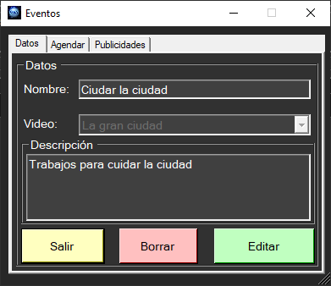

Agenda tab:

* Add button: Allows you to select a date or a date range and to schedule an event for that date.
* It also allows you to search for the events determined in a year on the right side. The delete button removes the event you are selecting.

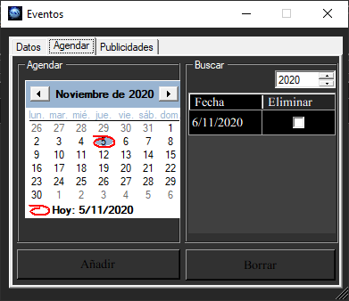

Advertisements tab: it shows a table with data from the advertisements that are related to an event, showing its name, the start date and the end date, with the delete button it removes that link between the event and the advertisement that is selected.

